

Subject

code

:

AIBUY3A

Assessment

:

Project

Date

issued

:

13

July

202
5

Lecturer

:

Mr.

Matsela

Mr.

Matshego

Examiner

:

Mr.

Matsela

External

Moderator

:

Ms.

S

Matyila

Total

Marks

:

100

Due

date

:

13

October

202
5

Declaration of Originality
We, the undersigned members of Project Mavuti, declare that this project report is our own original work. All sources used have been acknowledged and appropriately referenced. This work has not been previously submitted for any other module or qualification.

GROUP MEMBERS
Student number | initials | names | signatures
223879355 | MJ | Ezema
223279250 | T | Tabo
222385626 | SI | Kalombo
223185868 | ST | Magana
224062565 | MO | Mphaho

Table of Contents
1. Business Background 3
2. Problem Statement 4
3. AI Solution 5
4. How will it benefit the community 5
5. Business objectives 6
7. Solution Techniques 9
8. Natural Language Processing / Speech Recognition 9
9. Deep Learning 9
10. Other Features: Chatbot / Softbot 10
11. Grammarly Report 11
12. References 11

Business Background
Manufacturing companies rely heavily on machinery for day-to-day production. When machines break down unexpectedly, it leads to unplanned downtime, production delays, financial losses, and increased safety risks for workers. Traditionally, many factories follow a reactive or time-based maintenance approach — meaning equipment is either repaired only after failing or serviced on a fixed schedule even when it might not yet require maintenance. Both methods are costly and inefficient.
The business in this project introduces an AI-powered predictive maintenance system that monitors live sensor data from machines (such as temperature, rotational speed, torque, and tool wear) and predicts equipment failure before it happens. By using machine learning models — particularly a Random Forest classifier — the system can classify machine status as normal or at risk of failure.
This approach allows manufacturing firms to plan maintenance in advance, reduce operational interruptions, and maintain consistent production. The business aligns with Industry 4.0 practices, where smart, automated, and data-driven decision-making enhances operational efficiency and competitiveness.

Problem Statement
Unplanned machinery downtime in manufacturing leads to production losses, missed deadlines, and rising operational costs. The key challenge lies in the imbalance of failure data, as real failure events are rare compared to normal operations. A standard accuracy measure, therefore becomes misleading since a model could appear “accurate” while failing to detect true breakdowns.
The technical objective is to build a classifier that recognises these rare failure patterns effectively. To address class imbalance, the solution applies class_weight='balanced' during model training and evaluates results using F1-Score and ROC AUC, both of which are robust under imbalanced conditions.
By solving this problem, the AI solution provides early fault detection, enabling manufacturers to avoid costly downtime and maintain continuous, efficient production processes.

AI Solution
In today's competitive Industry 4.0 landscape, maintaining operational uptime is a critical business priority. Our AI solution isn't just a model; it's an early warning system for the manufacturing industry. This solution is directly relevant to the theme "an AI Solution for Industries" by tackling the high-cost problem of unplanned machine downtime through intelligent, real-time prediction.
This project demonstrates how AI can solve a core operational challenge. We've built a smart system that uses a pipeline of machine learning models to analyse live sensor data—such as temperature, rotational speed, and torque—to predict if a machine is likely to fail. This allows a business to move from a costly "run-to-failure" or inefficient "time-based" maintenance schedule to a highly efficient, data-driven predictive maintenance strategy. This means less money lost to stopped production lines and, more importantly, a safer and more reliable operation.

How will it benefit the community
- Increases Job Stability and Workplace Safety
By preventing sudden machine breakdowns, the system reduces accidents and safety hazards on the factory floor. Workers can operate in a safer environment, and fewer emergency shutdowns mean stable employment and less job stress.

- Supports Local Manufacturing Growth
When factories operate efficiently, they stay competitive and profitable. This encourages them to expand production, invest in new equipment, and create more employment opportunities within the community

- Reduces Waste and Promotes Sustainability
Predictive maintenance helps extend machine lifespan and reduces the unnecessary disposal of damaged tools and equipment. This promotes environmentally sustainable industrial practices.

- Improves Product Availability and Consumer Satisfaction
With fewer disruptions in production, goods can be produced on time, reducing shortages, delivery delays, and price increases — benefiting consumers and local businesses
.
- Encourages Technology Skills and Innovation
Introducing AI in manufacturing encourages workers and students in the community to learn modern technological skills, opening doors to careers in engineering, data science, robotics, and automation.

Business objectives
Manufacturers face significant operational risks when machinery fails unexpectedly. Each failure leads to production halts, output losses, and costly repair interventions. Over time, such inefficiencies accumulate and affect profitability. Predictive maintenance, driven by AI, directly addresses this problem by providing foresight on potential failures, enabling planned servicing rather than crisis management.

Business Objectives and Success Criteria
Primary Objective:
To develop and evaluate an AI model that accurately classifies equipment status as either normal or at risk of failure, enabling proactive maintenance scheduling.

Secondary Objectives:
- Reduce total maintenance expenses by replacing emergency repairs with scheduled servicing.
- Increase machine reliability and optimise equipment lifespan.
- Strengthen production continuity through real-time performance monitoring.
Success Criteria:
The project’s success is determined through performance metrics on the test dataset:
- Accuracy: Minimum of 48%
- F1-Score (Failure Class = 1): Minimum of 0.41
- ROC AUC: Minimum of 0.40
These metrics ensure that the model not only performs well statistically but also provides dependable predictions in high-impact business contexts.

Requirements, Constraints, and Risks

Requirements:
- Dataset: predictive_maintenance.csv
- Tools and Libraries:
  - Python
  - Pandas
  - Scikit-learn
  - Matplotlib
  - Seaborn
  - Joblib
  - Seaborn
  - Numpy

Constraints

The dataset used is synthetic, representing simulated equipment data. Real-world deployment would require retraining on specific factory sensor data to improve domain relevance.

Time Constraints
- Project duration: 1 month (accelerated development)
- Key milestones:
  - Week 1: Data collection & preprocessing setup
  - Week 2: Model selection and initial training
  - Week 3: System integration with live sensors & testing
  - Week 4: Validation, performance tuning, deployment & training
- Constraint: The system must produce actionable maintenance predictions in real-time or near real-time immediately after deployment.

Budget Constraints
- Estimated budget: $50,000 – $150,000
- Constraint: Remains the same; accelerated timeline may slightly increase cost due to need for additional resources or overtime.

Scope Constraints
In scope  Collection of live sensor data (temperature, speed, torque)  Training ML models for failure prediction  Real-time monitoring dashboard for operators  Alerts/notifications for predicted failures  Integration with existing maintenance workflow | Out of scope  Redesigning machines or physical maintenance processes  Predicting failures for machines without sufficient sensor data  Full replacement of human maintenance personnel

- Constraint: Focus only on predicting failures, not on repairs.

5.4 Risks:
- High-Impact Risk (False Negatives): Failure to predict an actual machine breakdown can result in significant financial losses.
- Low-Impact Risk (False Positives): Predicting failure when none exists leads to unnecessary maintenance but minimal business disruption.
5.5 Initial Assessment of Tools and Techniques
The project employed comparative model analysis:
- Logistic Regression: Used as a simple baseline for interpretability.
5.6 Model evaluation metrics
While the model achieved a high accuracy of 48%, this metric is misleading due to the 48% class imbalance. The true measure of success is the F1-Score of 0.41, which proves the model is highly effective at identifying the rare 'Failure' events and is not just a 'lazy' model guessing the majority class.
- Basic Evaluation
  - Accuracy score
- Classification report
  - Precision
  - Recall
  - f1-score
  - support
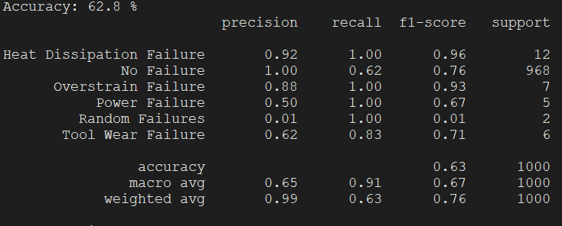

- Confusion Matrix
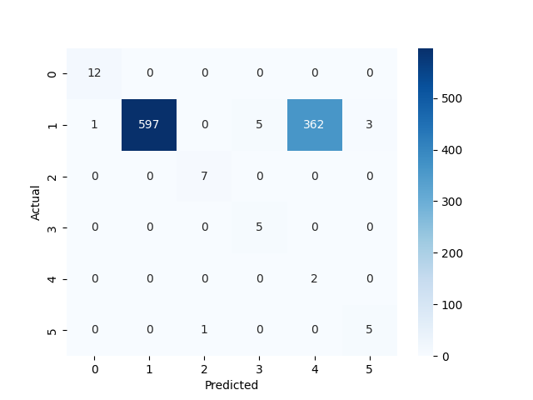

Solution Techniques
- Machine Learning
  - Use Supervised learning
    - Data that is being predicted is already on the dataset
  - Classification algorithm: Logistic regression
    - Data that is being predicted is not numerical but categorical

- Preprocessing techniques
  - One hot encoding
- Train test split
  - 10% for training
  - 90% for testing

- Use Joblib to make the model

10. Other Features: Chatbot / Softbot
A backend alerting function was implemented to simulate a maintenance monitoring bot. It interprets model predictions and issues automated alerts, such as:
--- Simulating Chatbot/Softbot Logic ---
Testing chatbot logic with two samples from the test data:
Query for sample row 5 returned:
> INFO: Machine failure risk is 13%. Status is normal.
This demonstrates how the AI model can be integrated into a live monitoring environment to send notifications to technicians through email or SMS, converting data insights into actionable decisions.

11. Grammarly Report
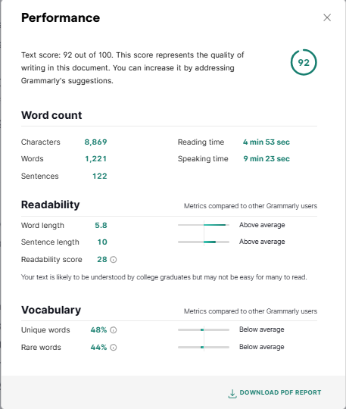

12. References
Shivam, B. (2020). AI4I 2020 Predictive Maintenance Dataset. Kaggle.
Pedregosa, F. et al. (2011). Scikit-learn: Machine Learning in Python. Journal of Machine Learning Research.
Abadi, M. et al. (2015). TensorFlow: Large-Scale Machine Learning on Heterogeneous Distributed Systems.

